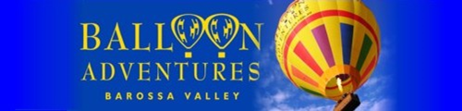

Name of tour:
Sunrise Balloon Flight
Starting Time:
2 hours before sunrise (time varies throughout year)
Duration:
Flight time one hour, whole experience, including breakfast, approx. 5 hours
Booking System:
Rezdy

BAROSSA BALLOON ADVENTURES RATES
Valid from the 1st of July 2022 to the 1st of July 2023
Note: All rates include GST
Passenger type | NETT Rate | Gross Rate
Adult | $262.50 | $350
Child (10-16) | $202.50 | $270

Contact person: Justin Stein
Barossa Balloon Adventures
Phone: 08 8562 3111
Mobile: 0428 623 110
E-mail: sales@balloonadventures.com.au

PO Box 410
NURIOOTPA SA 5355
ABN 8507 3897 856

