Good Morning,

We are pleased to share Spicers Retreats Preferred Client 20% Wholesale 2023/2024 Rates for all regional and urban retreats, as well as Scenic Rim Trail Walk.

The rates available for your international incoming clients, and group contract terms and conditions are attached for the following:

- Spicers Balfour Hotel, Brisbane
- Spicers Peak Lodge, Queensland High Country, South-East Queensland
- Spicers Hidden Vale, South-East Queensland Country
- Spicers Tamarind Retreat, Sunshine Coast Hinterland
- Spicers Clovelly Estate, Sunshine Coast Hinterland
- Spicers Vineyards Estate, Hunter Valley Wine region
- Spicers Guesthouse, Hunter Valley Wine region
- Spicers Sangoma Retreat, Greater Blue Mountains
- Spicers Potts Point, Sydney
- Spicers Scenic Rim Trail - multi day walks, Queensland High Country

We look forward to working with you closely over the coming 12 months to provide your clients with a unique Australian experience at Spicers Retreats!

If you have any questions at all, please do call or email me at any time.

Warm regards

Sarah

Sarah Bugenhagen l Director - Trade & Distribution
M 0476 815 807
E: sales@spicersretreats.com
122 Victoria St, Sydney NSW 2011
Lets connect on LinkedIn here

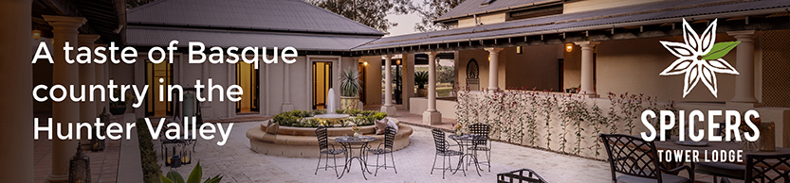

If you would like to book in a Spicers Retreat Product Update please book a time here on my calendar that best suits you here

