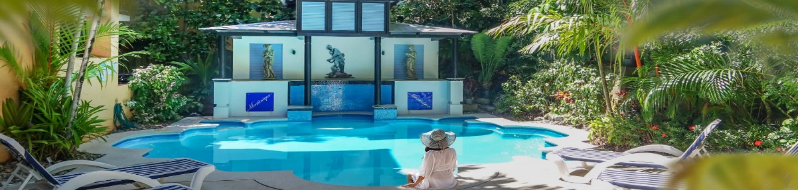
Martinique on Macrossan
66 Macrossan Street, Port Douglas, QLD 4871, Australia
Phone: 07 40996222 / Email: info@martinique.com.au / Web: www.martinique.com.au

Inbound Rates
1 April 2025 – 31 March 2026
The following rates are per night in Australian Dollars
Minimum 3 night stay rate
LOW SEASON
1 Nov – 19 Dec 2025,13 Jan – 31 March 2026

 | Weekly service
 | Gross | Nett
One Bedroom Deluxe | $215 | $161.25
MID SEASON
01-17 April 2025, 22 April – 31 May 2025 , 20 Dec 2025 – 12 Jan 2026
 | Weekly service
 | Gross | Nett
One Bedroom Deluxe (1-2 pax) | $280.00 | $210.00
HIGH SEASON
18 – 21 April 2025, 01- 30 June 2025, 01 - 31 October 2025,
(Port Douglas Carnival May 2025, Dates to be confirmed)
 | Weekly Service
 | Gross | Nett
One Bedroom Deluxe (1-2 pax) | $290.00 | $217.75
PEAK SEASON
1 July 2025 to 30 Sept 2025
 | Weekly Service
 | Gross | Nett
One Bedroom Deluxe (1-2 pax) | $309.00 | $231.75
- 1 Bedroom rates based on 1-2 persons
- Rates include a midweek service for stays 8 nights or longer.
- Daily Service available on request. Additional charges apply

Maximum Occupancy:
- 1 Bedroom Deluxe Apartment – 2 guests

Bedding Configuration– Subject to availability:
- 1 Bedroom Apartment - 1 x King or 2 x King Single

**Please note we do not cater for children 15 years and under. 16 years and older are welcome

Contact Details:
Street Address: Martinique On Macrossan
66 Macrossan Street, Port Douglas 4871, Australia
Mailing Address: Martinique On Macrossan
66 Macrossan Street, Port Douglas 4871, Australia
Telephone: (61) 7 4099 6222

Managers: Colin Earl & Ken Roberts
info@martinique.com.au

Accounts: Ken Roberts
Info@martinique.com.au

Reservations: info@martinique.com.au

Reception Hours
Our Reception desk is open Monday to Friday 8am to 5pm. Saturday and Sunday 8am to 1pm.
For after hour arrivals, full instruction and directions to the Apartment is advised by a welcome letter at reception desk. Guests who are arriving out of hours are required to contact the property prior to arrival to obtain instructions.

TERMS & CONDITIONS
Rates:
These rates are expressed in Australian dollars. Input Tax property. All rates are issued on the basis of confidential integrity. These rates are for future bookings and are valid for the dates specified in the contract. All bookings presently confirmed are to remain at the previously confirmed rate.

Check-in Time:
Check-in time is after 1400 hours.

Check-out Time:
Checkout time is 1000 hours.

Child Policy:
Martinique does not cater for children 15 years and under. 16 years and older adult rates apply

Cancellations - Policies:
All cancellations must be received in writing.
A cancellation charge of 100% of the booking will apply if cancelled within 14 days prior to arrival.

Payment:
Full pre-payment is required for all business unless prior credit facilities have been
granted. Once granted, vouchers will be accepted on your behalf. We adhere to a
strict 7-day payment on receipt of invoice requirement of all accounts.

Bank Details: ANZ
Account Name CEKA Group Pty Ltd T/A Martinique on Macrossan
BSB: 014696
Account Number: 415458793

ABN: 14159831928

Group Policy:
Will be confirmed only on a request basis.

Meals:
Are not supplied or included in the nightly tariff

Minimum Stay Requirement:
3 night minimum unless otherwise negotiated.

Airport Transfers:
Are not included with any booking but can be arranged at a cost directly to guest.

Acceptance:
We look forward to working with you in 2025/2026. I accept the attached rates for Martinique On Macrossan Port Douglas.

Signed: ____________ Name: ______________ Title: ____________ Date: ___________
(signature) (please print)

Property Description:-

Martinique is one of Port Douglas' best boutique apartments, blending luxurious comfort in a stunning setting. This charming Boutique Resort presents the ideal base for unwinding and exploring. Martinique is adjacent to the Port Douglas Village, with all its excellent Restaurants, street side Cafes, Boutiques and Art Galleries. Martinique is less than 5 minutes walk to Four Mile Beach.

Martinique is surrounded by lush tropical gardens with a saltwater swimming pool which is heated in winter. Here you can enjoy a good book from our library and relax on the sun lounges. Enjoy our free to use covered BBQ and outdoor dining. We also have a laundry with a coin operated washing machine and dryer, free Beach chairs, ice machine, free on site car parking and free WIFI through-out the property.

Our centrally located accommodation consists of 19 fully air-conditioned, self-contained, one-bedroom apartments with private balcony, bathroom and kitchenette. Featuring separate bedroom with a King-size bed (or King-size singles by request) plus a comfortable lounge and dining area, free WIFI, Foxtel and an in room Safe.

We do offer a disabled access apartment, located on the ground floor with easy access to all facilities. It has a master bedroom with ensuite which is wheel chair accessible with all the features of our other apartments.

Room Description:-

Spacious open plan 1 Bedroom Deluxe Apartment, tastefully furnished with modern furnishings offering the comforts of home in a tropical setting. Featuring master bedroom with ensuite, fully equipped kitchenette, complete with refrigerator, stove top/microwave, fully air-conditioned, ceiling fans, flat screen TV, free cable, free WIFI, in-room safe. You can relax on your own the private balcony or ground floor patio. We also have some inter-connecting rooms available on a request basis and subject to availability.
**interconnecting and Disabled room options are available**
Size 55 square meters

