Darwin Gourmet Tours

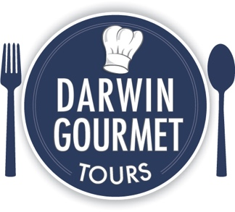
G’day!
We just hooked up with you on Rezdy, so FYI we’ve attached our tour info and confidential rates agreement.

Our new tours
5-Hour Distilleries Tour, Gourmet Meal & Sightseeing Rezdy P04UUD
Private 5-Hour Tropical Gardens Tour & Sightseeing Rezdy PALMSC
Forage for a Gourmet Feast & Sightseeing (ultra luxury) Rezdy PRSFQ9

Our existing tours
4-Hour Gourmet Food & Art Tour Rezdy PNQ437
5-Hour Tropical Gardens Tour & Sightseeing Rezdy PB0NCS
Full-day Tropical Gardens Tour, Gourmet Meal & Sightseeing Rezdy P3MEN7
Private Tour & Sightseeing By arrangement

Find out more
There’s lots of info about us in the attached documents.
Find even more at our website…
darwingourmettours.com
…including cleared photos to download, and even more photos here.
Tour name changes and tour scheduling
We’ve added sightseeing to many of our tours, and tweaked some tour names.
Many of our tours operate on demand, so contact us if you’d like us to open tour dates for you.
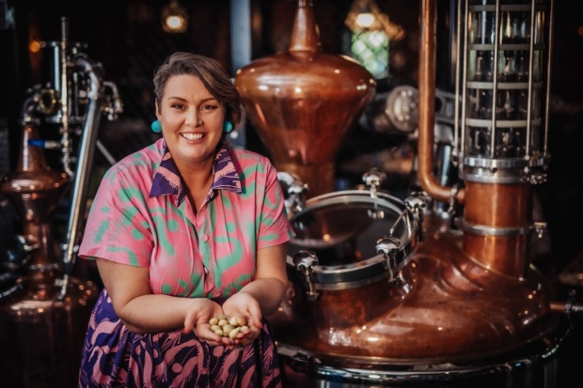
New! Distilleries Tour
Discover the magic behind award-winning spirits at two distilleries. To start the tour, we’ll put some food in your stomach with a gourmet lunch featuring the Territory’s finest ingredients, plus tropical dessert. Next, uncover the artistry of the distilling process as you learn about the unique flavors that define the Outback—some flavours found nowhere else in the world. From the invigorating zing of pepperberry to the exotic allure of quandong (native peach), each sip is a journey of discovery.
Tropical Gardens Tour
Enjoy a stroll through ancient bushland and learn about plants Aboriginal people used for food, medicine, tools, hunting and more. Also see a wide variety of spectacular native and non-native plants in large, mature gardens.
New! Ultra-luxury tour
Journey to the heart of Darwin’s rural area and stroll around a large private food garden. The garden’s owner will show you around and guide you in foraging for delicious fruits and vegetables. Then enjoy your harvest at a top restaurant, where your bounty is prepared in a gourmet meal with local ingredients such as crocodile, kangaroo and fresh seafood by an award-winning chef.
Our new accreditations
We’ve recently received accreditation for sustainability, limited mobility and much more.
See our website for details.
Darwin’s best guides
All of our guides have been in Darwin for over 15 years, and they look forward to treating you to the best Darwin has to offer. All guides are available for freelance hire. BTW, we can provide Chinese, French, German, Japanese and Spanish-speaking guides (and other languages) by arrangement.
Please don’t hesitate to contact me if you have any questions.



Thank you,
Darrel Trueman
Owner / Tour Director
+61 439 230 030 mobile
