PRODUCT UPDATES & DISTRIBUTION 25/26

Hi Simon Bernardi,

I hope this email finds you well. While we are in the midst of winter, our Uluru tours and private groups and charters have been keeping Hassie and the team busy.

We are happy to launch our 25/26 season and update you on some important product changes and new tours effective for the 24/25 season.

Our updated Agent OneDrive contains everything you need, including an essential Summary of Changes document outlining all the necessary product updates effective immediately.

You will also find rate sheets, updated itineraries, T&Cs, images and videos and various versions of our Trade Product Presentations.

Our annual product review is crucial to continuously improving customer experience. This process involves feedback from customers and the entire Untamed Escapes team, including our Storyteller Guides, who deliver these experiences. We understand it takes time to implement these changes on your end, and we thank you for your patience and understanding.

If you or your teams would like to catch up for product training, Hassie or I would be very happy to arrange this at a time that works for you.

Please don't hesitate to contact me by replying to this email if you have any queries.
We thank you for your ongoing support and look forward to showing your clients the best of our untamed regions.

Warm regards,

Anna Heaton
Business Development & Marketing Manager
Untamed Escapes
anna@untamedescapes.com.au

NEW PRODUCT
1-Day Port Lincoln & Coffin Bay Tour

We are very excited to launch a new product!

While we offer a 1-Day Port Lincoln Tour and a 1-Day Coffin Bay Tour, there are no small group tours from Port Lincoln that showcase both on the same day.

Our fabulous new one-day Port Lincoln & Coffin Bay Tour blends nature, wildlife, and culinary delights to unearth the best of the Eyre Peninsula.

HIGHLIGHTS:
- The untamed scenery of Whalers Way
- Koalas and other wildlife at Mikkira Station
- Immersive Coffin Bay Oyster Farm Tour, including waders and oysters
- Lunch at Oyster HQ restaurant
- Wine tasting at Peter Teakle Wines
- Storytelling from our expert local guide
This small group tour has a maximum of 20 people and departs every Saturday from October 2024.

PRIVATE TOUR UPGRADE

If your clients would like to travel in their own group in a 4WD, as with all of our tours, there is a private upgrade available. This will also allow for an off-road adventure in Lincoln National Park, along with a premium lunch menu at Oyster HQ.

Private tours are available from now on, seven days a week, on request.

View itinerary and images.

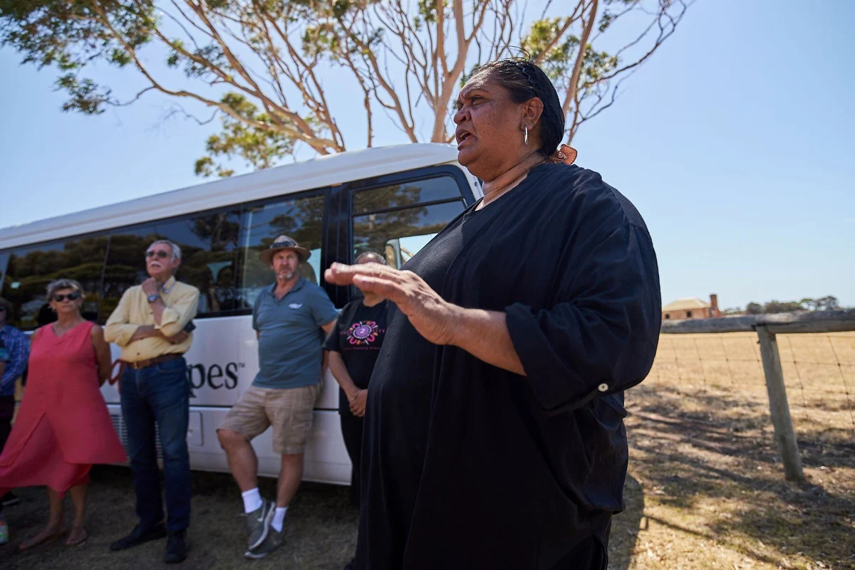
NEW CULTURAL TOUR TO BE LAUNCHED SOON

Hopefully, by now, you have seen the Press Release sent in July with the news of our partnership with Emmaline Richards from Maba Idi.

Building on the success of the Cultural Cruise Ship Tour, a scheduled 1-Day Cultural Tour from Port Lincoln, will be launched in September and distributed to our trade partners worldwide.

View Media Release and images

View Story on ABC News

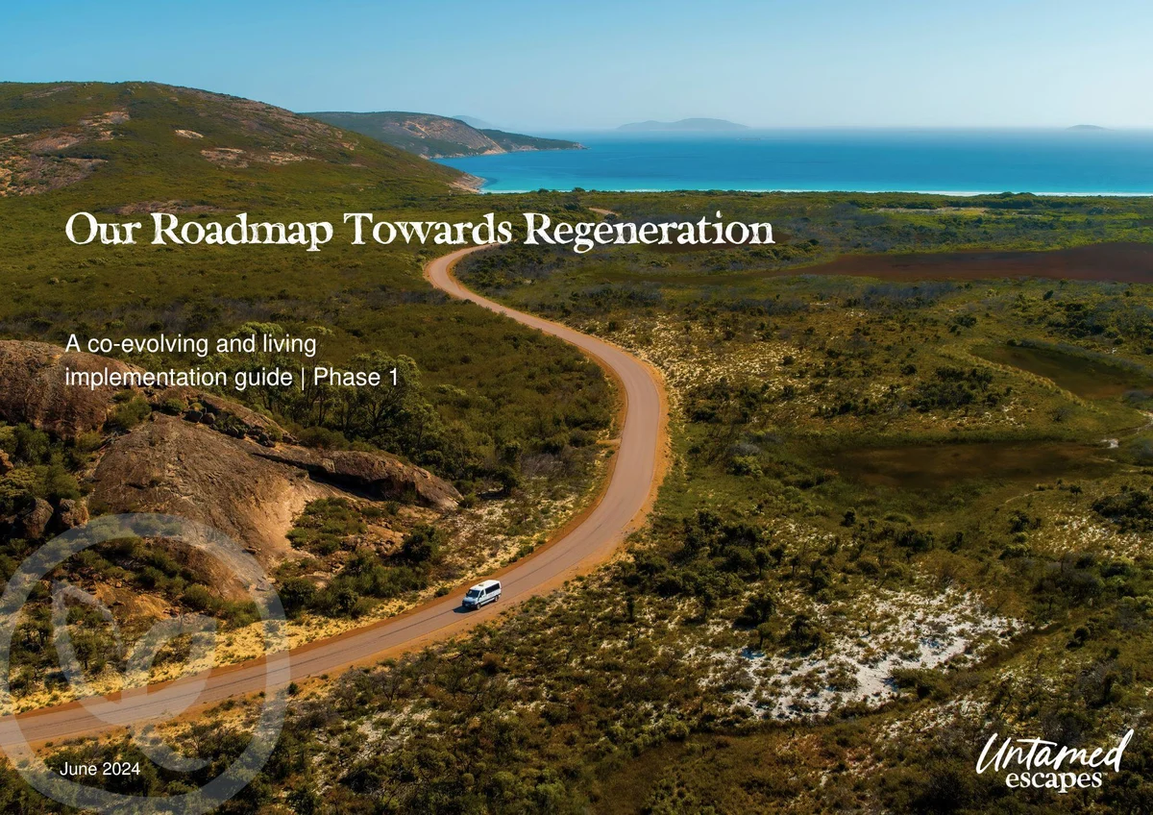
REGEN NEWS
Roadmap Towards Regeneration Launched

July was a busy month! After a two-year journey, we were delighted to also introduce our Roadmap Towards Regeneration. This co-evolving implementation guide includes actionable steps that will assist us in identifying, measuring, developing, and implementing regenerative initiatives across our business departments. We have made this framework freely available as a source of inspiration and guidance that can be adapted to suit other tourism business ecosystems.

View Media Release

  
  
  
  
  
  

Australian Wildlife Adventures Pty Ltd trading as Untamed Escapes, Unit 3/60 Tasman Terrace, Port Lincoln, SA 5606, Australia, +61 8 8687 0455
Unsubscribe Manage preferences
Send free email today


