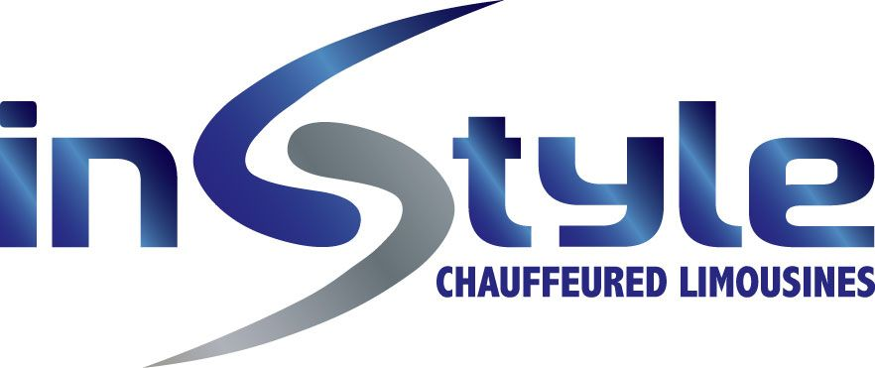

Phone +61 2 9017 1930
EMAIL: res@instylelimos.com.au
ADDRESS: UNIT 2, 17 GREEN ST BANKSMEADOW NSW 2019

DAY TOURS – ENGLISH DRIVER GUIDE SERVICES

01/04/2026 to 31/03/2028

HALF DAY CITY TOURS (4HRS)

LUXURY SEDAN $530.00
LUXURY 7 SEATER MPV $660.00
11-14 SEATER $935.00
22-24 SEATER $1100.00
43-53 SEATER $1450.00

FULL DAY CITY TOURS (8HRS)

LUXURY SEDAN $975.00
LUXURY 7 SEATER MPV $1200.00
11-14 SEATER $1500.00
22-24 SEATER $1950.00
43-53 SEATER $2300.00

FULL DAY BLUE MOUNTAINS TOUR (10HRS)

LUXURY SEDAN $1400.00
LUXURY 7 SEATER MPV $1600.00
11-14 SEATER $1900.00
22-24 SEATER $1950.00
43-53 SEATER $2500.00

FULL DAY HUNTER VALLEY WINERY TOUR (10HRS)

LUXURY SEDAN $1400.00
LUXURY 7 SEATER MPV $1600.00
11-14 SEATER $1900.00
22-24 SEATER $1950.00
43-53 SEATER $2500.00

Note:

Entry to Featherdale Wildlife Park or Sydney Zoo included for Full Day Blue Mountains Tour

Wine tasting fees (if any) are included for Full Day Hunter ValleyTour

Lunches and other attraction entry fees not included but can be added as an optional extra as follows:

Lunch - $85pp
Lunch + Scenic World - $140pp

All services are inclusive of GST, airport parking and tolls where applicable

Surcharges

Child Seats - $20 per seat (ages 0-7)
Christmas Day – 50% surcharge applies
New Years Day – 50% surcharge applies

Cancellation Policy
Within 24hrs of service – Full charges applicable
Outside 24hrs of service – No charges applicable

