3D/2N LUXURY GRAND TOUR

Day 1 - SYDNEY to BLUE MOUNTAINS
Today get ready to embark on an unforgettable 3-day, 2-night journey across some of the most amazing places NSW has to offer.
On day 1, we will depart your hotel at 07.30am for the first leg which will be a full day Blue Mountains tour. Our first stop will be at Featherdale Wildlife Park where you will have the opportunity to handfeed kangaroos, get up close and personal with a cuddly Koala, see wombats, emus, dingoes, crocodiles and a whole lot more.
We will depart Featherdale at approx 09.30am and continue onto Glenbrook where we will discover the remarkable beauty of Blue Mountains National Park. Here you will enjoy a scenic 4WD experience and will visit amazing sites like Red Rock Hand, Jellybean Pool & Euroka Clearing. From here we will pass through the quaint little village of Leura before continuing around Cliff Drive to Katoomba and Echo Point where you will find yourself looking out over the magnificent Jamieson Valley (Australia’s Grand Canyon) & the Three Sisters. Enjoy captivating panoramic views of these rugged cliffs separated by deep valleys covered by a thick carpet of eucalyptus trees.
We will depart Echo Point and travel to Scenic World to arrive at approx. 12.30pm. Get ready to enjoy a thrilling ride as you travel down into the rainforest on the steepest railway in the southern hemisphere. Once you reach the bottom you can enjoy an amazing walk through the rainforest with incredible views of the beautiful Three Sisters, before taking the cable car back up to the top of the mountains. We now head off to the Hydro Majestic Boiler Room for a magnificent lunch overlooking the valley.
After lunch, travel to Govetts Leap, one of the most famous lookouts in Australia. Take in the panoramic, sweeping views of Govetts & Grose Gorge and a thundering waterfall dropping 590 feet straight down. Continue to Mt Tomah Botanic Gardens, where you will enjoy lovely views of the surrounding terrain before departing to your hotel.
(Overnight accommodation with Dinner & Breakfast included)

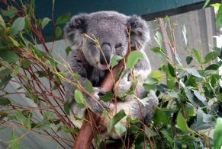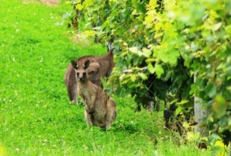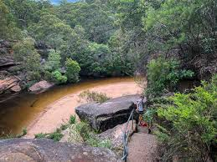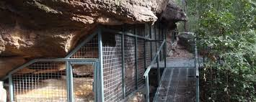
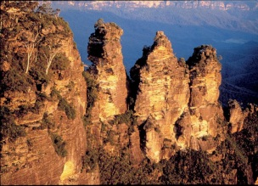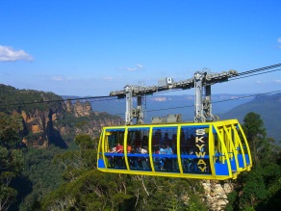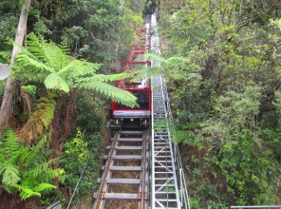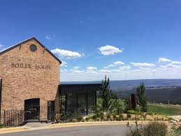
Day 2 - BLUE MOUNTAINS to HUNTER VALLEY
On day 2, we will be departing your hotel at 08.30am to travel to the Hunter Valley. Enjoy a beautiful morning scenic drive through Wollemi & Yengo National Parks with a pit stop at the famous Grey Gum International Café for some refreshments. We depart Grey Gum and continue on to the Hunter Valley with our first stop being at Margan Winery at approx. 11am where you will be able sample a wide range of beautiful Australian wines. From here we will continue on to visit numerous wineries throughout the day with a sumptuous gourmet lunch at one of Hunter Valley’s most famous wineries, Petersons House. After lunch we will head across to the Hunter Valley Gardens where you will enjoy some free time before retiring to your hotel for the night.
(Overnight accommodation with Dinner & Breakfast included)

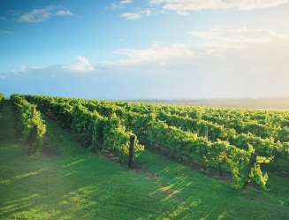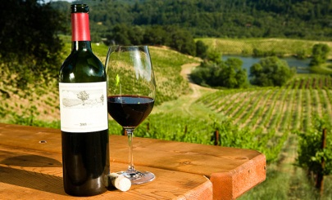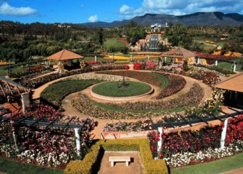

Day 3 - HUNTER VALLEY to PORT STEPHENS to SYDNEY
For our final day, we will be departing your hotel at 08.30am for our full day tour to Port Stephens. Our first stop will be at Nelson Bay. Here you can enjoy the beauty of Nelson Bay marina before hopping on board a Dolphin or Whale watching cruise at 10.30am (duration of cruise is 1.5hrs). Once disembarking off your cruise we will head up the coast to Anna Bay where you will enjoy a thrilling 4WD and Sandboarding experience on the sand dunes of Stockton & Birubi Beach. Afterwards we will head to Crest Café at Birubi Beach for lunch which has sweeping views across the beaches & NSW coastline.
After lunch sit back and relax for the drive back to your Sydney hotel or airport.

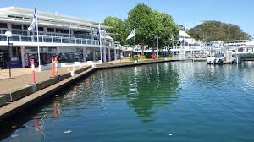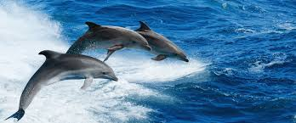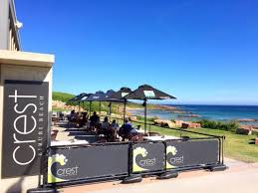
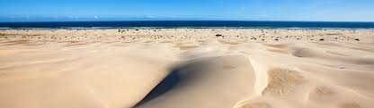

PACKAGE NET RATE (VALID FROM 01.04.2026 to 31.03.2028)

LUXURY SEDAN - $5250 (based on 2 pax travelling)
LUXURY PEOPLE MOVER - $7900 (based on 4 pax travelling)
LUXURY MINIBUS - POA

Package inclusions are:
- 3 days private luxury vehicle with a professional driver/guide at 10hrs per day
- 2 nights’ accommodation incl dinner and breakfast
- Entry fees for all attractions and experiences
- Lunches on all touring days

Surcharges
Child Seats - $20 per seat each way (ages 0-7)
Christmas Day – 50% surcharge applies
New Year’s Day – 50% surcharge applies

Cancellation Policy
Within 7 days of service – Full charges applicable
Outside 7 days of service – No charges applicable

