From: Caitlin Sewell <caitlin@gltg.com.au>
Sent: Friday, 10 October 2025 7:05 PM
To: AABH Info <info@aabh.com.au>
Subject: Now Live: Autopia Tours 2026–27 Agent Toolkit + New Comfort-Level Tours

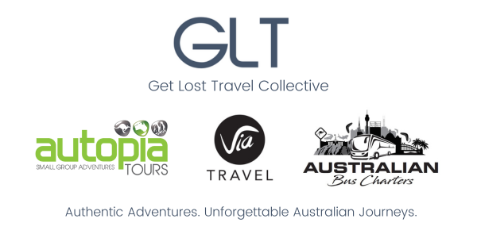

New Season, New Horizons

Autopia Tours Unveils New Experiences

We’re thrilled to unveil what’s new for the 2026–27 season across Australia – including expanded touring options, updated agent resources, and even more reasons to sell Autopia Tours.

With the recent acquisition of Via Travel, Autopia Tours is proud to now offer a curated selection of comfort-level small group experiences – perfect for travellers seeking elevated accommodations, relaxed pacing, and premium inclusions.

These new tours sit alongside our Original and Adventure-style journeys that your clients know and love – giving you more flexibility and variety to meet every traveller’s needs.

Visit our site

Our Agent Toolkit
To help you plan and promote the season ahead, your 2026-27 Agent Toolkit includes:
- Product Fact Sheets – Featuring new comfort-level itineraries
- Departure Schedules – Across all regions and product categories
- High-Resolution Image Library – Updated for your marketing needs
- Updated Terms & Conditions – Effective for 2025 onward
[Download our Agent Toolkit]
[Access 2026-27 Retail Rates]
[View Terms & Conditions]

Need FIT/SIC Sightseeing Rates for 2026-27?

If you haven’t yet received your FIT/SIC commissionable rates, or require booking portal access, please contact: caitlin@gltg.com.au.

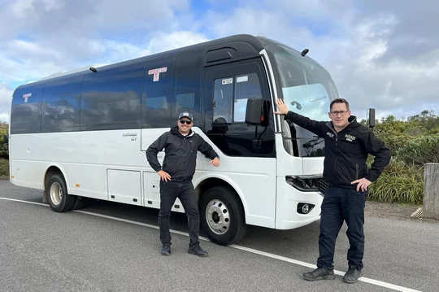

Private Groups, Series Touring & Charters

Looking to book a private group, custom tour, or group series package. Our charter experts at Australian Bus Charters are ready to help: charters@gltg.com.au.

Whether your clients are after rugged, off-the-beaten-path adventures or comfort-driven small group escapes, Autopia Tours now offers a broader range of experiences – all with our signature eco-conscious, culturally respectful approach.

Thanks for your continued support. We look forward to working with you for a big 2026–27 season and beyond!

Warm regards,
Caitlin Sewell
& The Autopia Tours Team

Autopia Tours, now joined by Via Travel, is proud to offer a wider range of authentic Australian journeys – from rugged adventures to comfort-driven escapes – all delivered with a deep commitment to sustainability, cultural engagement, and connection to community.



  
  
  
  

Get Lost Travel Pty Ltd, 42 Macaulay Street, Williamstown North, Victoria 3016, Australia, +61 3 9393 1333
Unsubscribe Manage preferences

