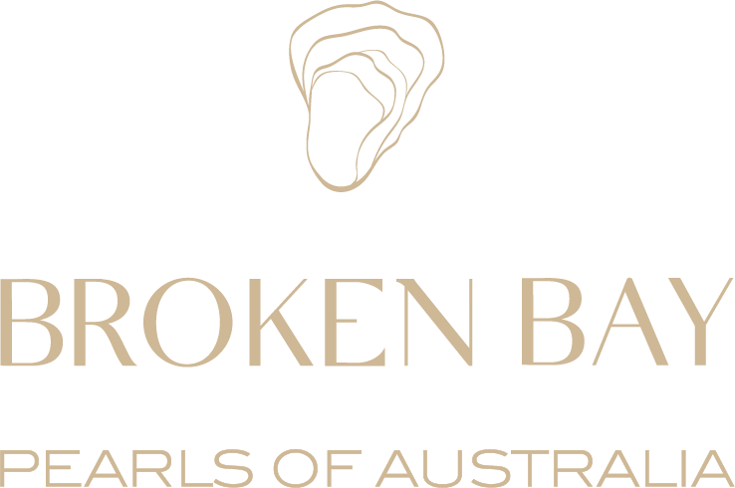

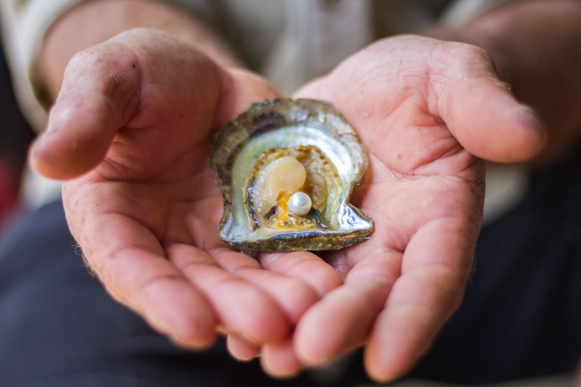

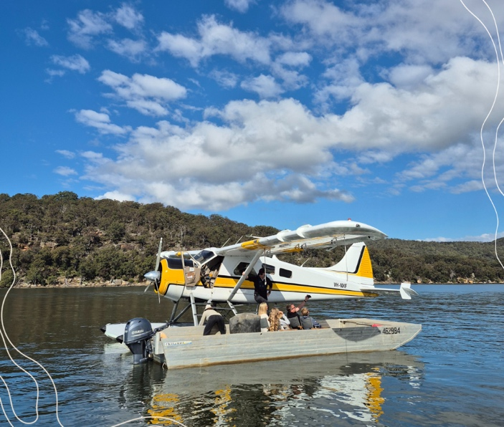
Dear Simon
We are excited to introduce the ultimate Sydney adventure!
Sydney Seaplanes and Broken Bay Pearl Farm have joined forces to deliver a truly one-of-a-kind experience, just a short distance from the city.
Begin your journey with a breathtaking seaplane flight from iconic Sydney Harbour, gliding over sparkling coastlines, hidden beaches, and the winding waterways of the Hawkesbury. Touch down on the river at Broken Bay Pearl Farm — NSW’s only pearl and oyster farm — for the exclusive Shell to Showroom experience. This intimate, behind-the-scenes tour reveals the fascinating story of the Australian Akoya pearl, from nurturing oysters in pristine waters to the careful grading that defines each gem’s beauty and value.
Indulge in a gourmet lunch of freshly shucked oysters and a grazing platter, paired with fine wine, while overlooking the same waters that produce these rare treasures.
Your journey ends with a choice of return: either take to the skies once more, flying past the Opera House and Harbour Bridge before landing at Rose Bay, or relax with a luxury car transfer direct to your Sydney hotel.
A seamless blend of luxury travel, riverfront dining, and natural beauty — crafted for those who seek the very best. Where sweeping horizons meet the ocean’s rarest gems.

Oysters & Seaplane adventure 25/26 inbound rates

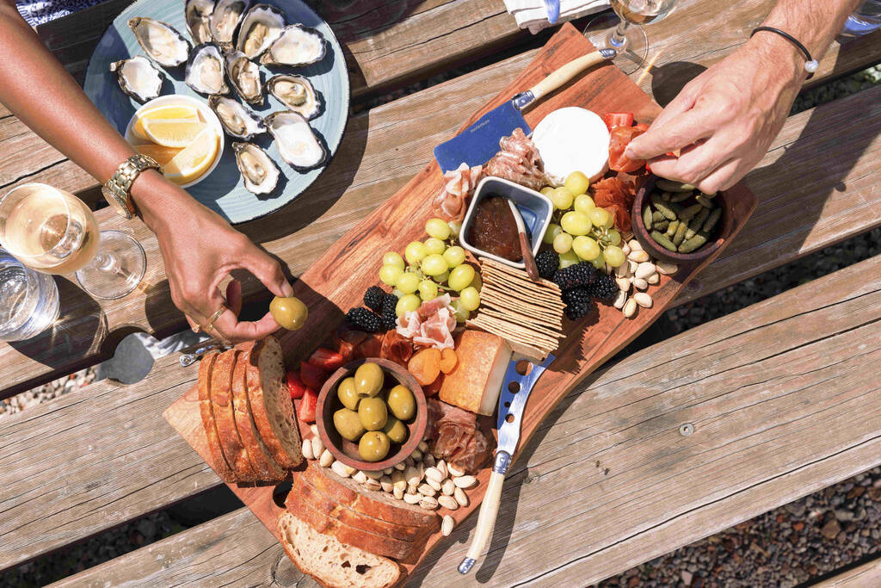
If a Seaplane isn't for you, we are also excited to offer a Private Shellar Door Experience with Luxury Sydney Transfer. This exclusive guided tour offers your guests in the fascinating world of oyster and Akoya pearl farming, live pearl reveal and a hand-on grading experience. Cruise through the scenic waterways to working oyster leave then savour the flavours of the river with a groumet riverside lunch.

Private Shellar Door Experience with Luxury transfers 25/26 rates

Pearls of Australia 25/26 rates (other products)

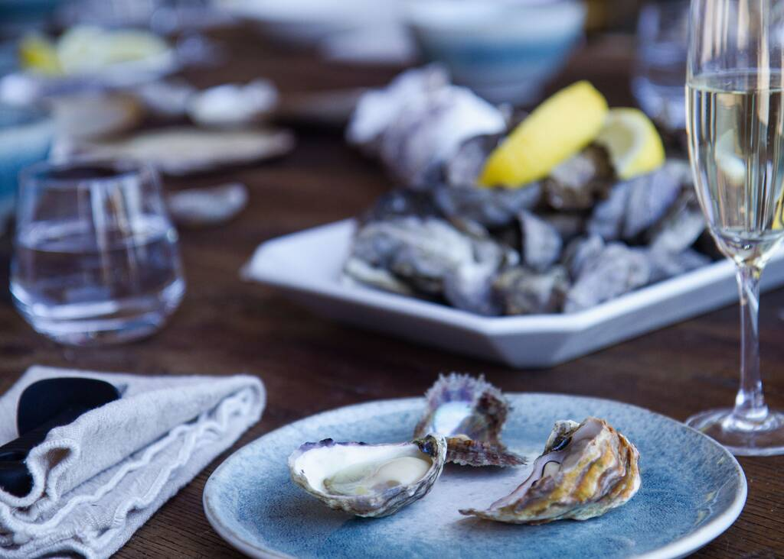
Please note 26/27 rates will be sent out shortly for all Pearls of Australia products.
All bookings can be sent to hello@brokenbaypearlfarm.com.au,
For product enquiries, please contact Julia at bdm@pearlsofaustralia.com.au or your contact at Australian Attractions below.
Cheers
Louize, Ken, Nathan and Eva
The Australian Attractions Team
louize@australianattractions.com.au
nathan@australianattractions.com.au
eva@australianattractions.com.au

