Baunti Portal
From: Accounts at Baunti Tours <accounts@baunti.nlk.nf>
Sent: Thursday, July 21, 2022 2:58 pm
To: Simon Bernardi
Subject: RE: Wholesale Rates

Hi Simon,

I have set you up to book online via our website as requested.
Here are a list of basic steps for you to look at.

- Go to our website and you will see an Agent Login on the top left hand of the screen
- Sign in with your Username and Password
- I have set up a ‘Favourites’ list which is basically just our Baunti Tours to make it easier for staff to click on the tour required
- Click on the required tour or New Booking, then choose your tour by either clicking on the tour – or using the search box
- You can check availability and it will show you how many seats we have left…choose your date
- Then Click on Book Now
- Add in the amount of Adults/children etc.
- Fill in the passenger details.
- Meeting Point – is the pickup point your clients will be picked up for the tour – we only pickup from accommodations that are located in the Burnt Pine town area. If in doubt always choose our Baunti Tours office location.
- Accommodation On Island (& Travel Dates please)– where they are staying on Island and their travel dates as well – this information is very important
- When you get to the Booking price it will show you how much commission you will get –
- 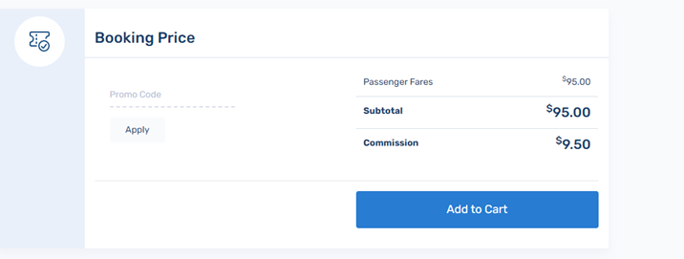
- Finalise Booking - Leave the Customer Information with pax names - You can add in your email address to the Customer information if you don’t want the confirmation to automatically send to your client.
- The price will always show the Gross amount – so that your client doesn’t see the commission rate.
- Agent Ref – is your booking number.
- Agent voucher can be left blank
- Then add to cart
- If you would like to book more than one tour – you will see a CONTINUE SHOPPING at the bottom of this screen to proceed with more bookings.
- Tick to agree to terms and conditions – then next.
- Tick payment option 1 – full credit – then confirm. Your booking will be automatically confirmed in our system.

If you wish to cancel a booking, you will need to contact us via phone or email.

Your login Details are as follows;
Username: Simon
Password: aabh1

If required I can set up more users – I will just need their names and email address.

Our account details are as follows;
ACC NAME: Baunti Tours
BSB: 062 950
ACC: 1011 2189
Commonwealth Bank, Norfolk Island

When making payment, please use Clients Surname and our booking number.

Hope this helps. Let me know if you have any further questions.

Have a lovely day 😊

Kind Regards,
Deb

